Overdale Community Primary School
Year 4 Autumn Term 1 - 2023
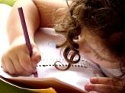  Literacy  In literacy, we are going write our own setting descriptions using effective language to help the reader visualise our setting. We will use noun phrases, prepositions extended our sentences using and conjunctions. We will also be writing newspaper reports focusing on correct speech punctuation and using the correct tense when writing. This is alongside our continued practise of our year 4 spellings and grammar sessions. | 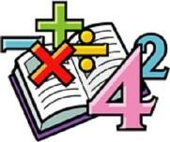  Maths  In maths, we are going to focus on further understanding of place value with numbers up to ten thousand. We will also further our addition and subtraction knowledge before half term. We will keep practising our times tables and division facts to make sure we are secure with these. | Science  In Science, the children will identify, sort and group animals and plants into categories based on their features. They will learn about different types of mammals and how we can sort them into different ways. The children will also identify different plants and how they can be classified. | 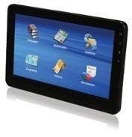  Computing  We will begin our computing curriculum in Year 4 with internet safety. The children will learn about search engines and how they try to persuade and encourage us to buy online. This includes whether something we find online is fact, belief or opinion. We will also investigate our own technology timetables to see how we can use our time on technology wisely.
Humanities  In history we are going to learn all about Britain’s settlement by Anglo Saxons and Scots. The children will learn all about Anglo Saxon life, why and how they settled in Britian and how they changed Britian. | 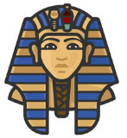  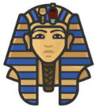  Whole Class reading book:  The Children of Swallow Fell – Julia Green  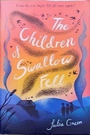 |  | 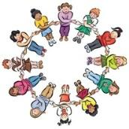  PSHE  We will explore what being a good friend involves. The children will remind ourselves about the importance of good manners as well as what a healthy friendship looks like. We will also talk about how our own behaviour can affect others.
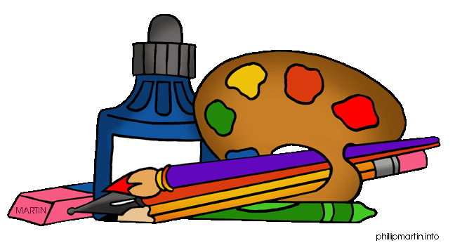  Art  This half term we are going to look into formal methods of art. This includes abstract mark marking using charcoal, making patterns using printing and stamping techniques and using reflection and symmetry to make creative artwork. | PE  In P.E we will be taking part in outdoor activity challenges both individually and within a team. We will use and improve our agility, balance, coordination and precision in order to play basketball.  We will also be taking part in dance lessons, which will be Egyptian themed! | French  In French we will learn all about describing people in French. This will both orally and in written form. | RE  We are going to find out about Hindu beliefs and customs and how Hindus express their faith in Britain today.

